**Assignment 2 Cover Sheet**



**BSc (Hons) in Information Technology**



**IT1060 – Software Process Modeling Semester 2** - **2023**

|  |  |
| --- | --- |
| **PROJECT ID** | MLB_4.1_04 |
| **CASE STUDY NAME** | Vehicle insurance management system |
| **CAMPUS/CENTER** | Malabe |

**Group Details:**

|  |  |  |
| --- | --- | --- |
| 1 | IT22316486 | HEWAGAMA A D |
| 2 | IT22887108 | KUMARAGE N D |
| 3 | IT22336590 | SIRIWARDANA B J A |
| 4 | IT22326904 | ALWIS D A C |
| 5 | IT22338334 | SHEHARA I G D S |



 **Assignment 2 Certify Sheet**

**IT1060 – Software Process Modeling Semester 2** - **2023**



**BSc**

**(**

**Hons) in Information Technology**



|  |
| --- |
| We hereby certify,  The attached is our own work and no further changes will be made.  We have contributed in this assignment to the best of our ability.  And we understand,  We may be subject to student discipline processes in the event of an act of academic misconduct by us including an act of plagiarism or cheating. |

|  |  |  |  |
| --- | --- | --- | --- |
|  | **Student Registration** |  |  |
| **Student Name** | **Number** | **Date** | **Signature** |
| KUMARAGE N D | IT22887108 | 27/05/2023 | Naveen |

**Student Details:**



|  |  |  |
| --- | --- | --- |
| **Number** | IT22887108 | |
| **Name** | User management | |
|  |  | |
| **Summary** | Manage the customer account | |
| **Pre-conditions** | Visit profile page and click update button | |
| **Post-conditions** | Successfully update details | |
| **Primary Actor** | Registered User | |
| **Main Scenario** | **Step** | **Action** |
|  | 1 | User click register button |
| 2 | System directed to the register page |
| 3 | User enters the details |
| 4 | System directed to update user profile page |
| 5 | User enter the update profile details |
| 6 | User is directed to profile page |
| 7 | User can view the profile |
| 8 | User can track the points |
| 9 | User can maintain the profile |
| **Extensions** | **Step** | **Action** |
|  | 5a | User change email |
| 4a | User update profile picture |
| 8a | User track points of updated profile |
|  |  |



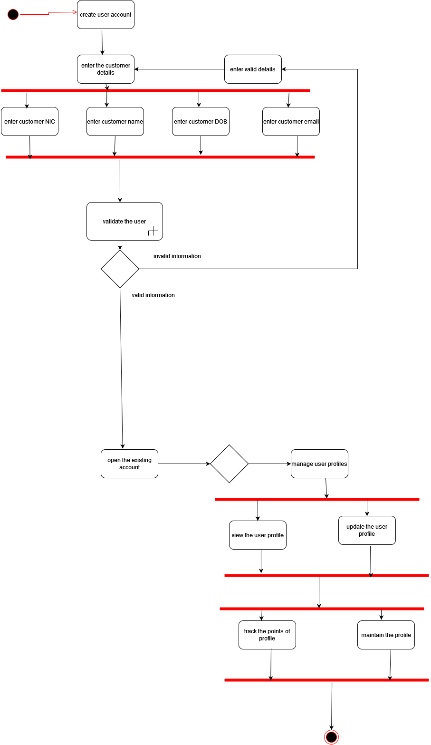

**Validate user.**

v

